**Document Control**

|  |  |
| --- | --- |
| Product Owner | Matthew Goldsbrough |
| Test Lead | Arunkumar |
| Date |  |
| Version | V1.0 |
| Classification | Experian Confidential |

**UK & I Solution Division**

**SME Lending Initiative - Bosun**

**Test Strategy**

Document Owner

|  |  |
| --- | --- |
| Name | Role |
| Arunkumar Aickarakunnel Ammini | Test Lead - Bosun |

Approval

Following approval, this document will be base-lined by promoting it to a major version number (e.g. 1.0), recording the names and positions of approvers in the Approval Record and, if applicable, accepting all tracked changes. The Approval Record can be found in the Document Control Appendix at the end of this document.

A soft copy of email approvals will be maintained and stored as a permanent record of acceptance of this document.

Change Control

This document is subject to change control. All requests for change should be referred to the document owner.

The Change History can be found in the Document Control Appendix at the end of this document.

Distribution

|  |  |  |  |
| --- | --- | --- | --- |
| Name | Role | Reason | Departments |
| Matthew Goldsbrough | Product Owner | Review |  |
|  |  |  |  |
|  |  |  |  |

**Contents**

1. Introduction 4

1.1 Document Purpose 4

1.2 Overview SME Lending Initiative- Bosun 4

2. QAT 5

2.1 Scope 5

2.1.1 In Scope 5

2.1.2 Out of Scope 5

2.2 Test Approach 5

2.3 Requirement & Plan 6

2.3.1 PI Planning 6

2.3.2 Static Testing 7

2.3.3 Sprint Planning 7

2.3.4 Task Allocation 7

2.3.5 Re-estimations 7

2.4 Test Development (Design) 8

2.4.1 In Sprint Functional Tests 8

2.4.2 Regression Tests 8

2.5 Test Execution 8

2.6 Test Automation Framework 9

2.7 Version Control 9

2.8 Non - Functional Testing 9

2.8.1 Performance Testing 9

2.8.2 Multi browser Testing 10

2.9 Test Data Management 10

2.10 Sprint Closure Activities 10

2.11 JIRA work Flow of a Story 10

2.12 Test Environments 11

2.13 Test Tool Set 11

2.14 Defect Management 11

2.15 Work Flow 11

2.16 Defect Priorities 11

2.17 Defect SLAs 11

2.18 Defect Triage & Roles 12

2.19 Test Management Governance 12

2.20 Team structure 12

2.21 Escalation Matrix 13

2.22 Team Meetings 13

2.23 Roles and Responsibilities 13

2.23.1 RACI Matrix 13

2.24 Risk & Issues 14

3. User Acceptance Testing (UAT) 14

3.1 UAT Approach 14

3.2 Assumptions 15

4. Appendix 15

4.1 Change History 15

4.2 Approval Record 15

4.3 Definitions and Acronyms 15

# Introduction

## Document Purpose

This Test Strategy document provides readers a view of the test approach that is adopted for the SME Lending Initiative- Bosun project releases. It also talks about the tailored QA processes that is aligned with the agile methodology employed in the project releases. It encapsulates the test approaches adopted for non-functional tests, specifications on the test environment, test data management processes and defect management process.

## Overview SME Lending Initiative- Bosun

The primary objective of the Bosun project is to develop a screen-based application which covers the MVP user journey for SME affordability check.

The application supports the aggregation and analysis of small business data helping lenders to understand the unique risk profile of each small business and improve lending outcomes for both parties.

The following functionalities will be delivered as part of PI4

1. Under writer portal
   1. Login
   2. Application Set-Up
      1. Business Search
      2. Director search & Authentication
      3. Director Address search
      4. Submit Data share request to SME
      5. Send an email to SME
   3. Application Search
   4. Download options for Open banking & Accounting data for the selected applications
   5. Review and complete applications
2. SME portal
   1. Login
   2. Data sharing page/ Dashboard
   3. Consents
   4. Enable to connect open banking
   5. Enable to connect Accounting Packages
   6. Download options for Open banking & Accounting data
   7. Submit data back to Lender
   8. Email notifications
3. Super user Portal
   1. Lender onboarding

# Quality Assurance Testing (QAT)

## Scope

### In Scope

In-scope testing activities for Boson project is given as below:

* Static Testing
* System Testing
* Automated Regression Testing
* Performance testing
* Test Data Management
* UAT Support

### Out of Scope

The following items are out of Scope for the QA team.

* Unit Testing

Unit testing will be performed by the development team and will target for 80% coverage for new requirements. QA team will have a quality gate to validate for the code coverage. Dev team will publish coverage report for new features new builds.

* User Acceptance Testing: UAT will be performed by BI UAT team
* Security Testing: Security Testing currently performed by a separate team
* Sprint Level Performance Testing

## Test Approach

PI.4 Bosun will be using SAFe as a framework for delivery. Our goal is to run different types of tests—both manual and automated—continually throughout the delivery process.

The proposed testing approach is laid out in the below diagram.

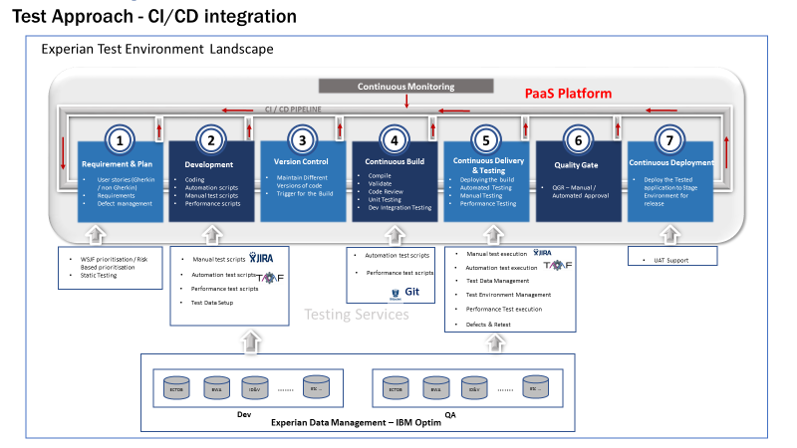

Once the dev-ops platform is ready with automation framework and JIRA is integrated, the testing will be shifted to CI/CD mode. Every change/commit runs a build that creates packages and deploys it into the QAT environment. On successful completion of QAT deployment, the automated regression and functional tests run against the build.

The test results are captured in JIRA with a Quality gate defined. Based on the quality gate definition, the next level deployments start automatically.

Pipeline setup and Integration of TAAF to the pipeline will be done by Test enablement team. Test Delivery office is responsible for the same.

## Requirement & Plan

It is agreed to have refined user stories in JIRA which QA team can readily use for static testing. The story will be added into JIRA by product owner. Following section enlist the activities under Requirements & sprint pre-planning.

### PI Planning

The onsite team members join two days of PI planning meeting for aligning with Agile Release Train. This meeting will be conducted in one of the Experian offices and all stakeholder will be available. The below list explains the various activities that are included in a PI planning meeting.

* Introduction
* Epic overviews
* Product Owner’s Vision
* Architectural Overview
* Several iterations of Team Breakouts:
  + What features to be released, when to be released and identify dependencies
  + Brake down the features into user stories and size them
  + Align user stories to Sprints based on dependencies
* Scrum of Scrums – to synchronise, share and resolve impediments across teams
* Management Play-back and feedback gathering
* Vision and committed plans sharing
* Confidence Vote for the plan
* PI Planning retrospective

The team use story points and ‘estimating poker’ to value their work. The story points are relative, without a connection to any specific unit of measure. The size (effort) of each story is estimated relative to the smallest story, which is assigned a size of ‘one.’ A modified Fibonacci sequence (1, 2, 3, 5, 8, 13, 20, 40) is applied that reflects the inherent uncertainty in estimating. Test estimates will be matured based on the actual data from the sprints later. The sizing is for the entire team for delivering the story.

### Static Testing

Static testing will be performed to User Stories which are reviewed and approved by the Product Owner. This process is designed to identify the defects related to requirements early in the software life cycle and thereby reduce costs of defect resolution in later phases. This includes a standard set of questions to be applied against each requirement. The QA team will use the static testing questionnaires which are available in JIRA.

Static testing will be done in the beginning of the sprint and the results will be fed back to the product owner. The queries will be updated in JIRA itself for clarification and remedial action. Defect will be created if any specific action to be performed by product owner e.g. Creation of new story/ follow up with third party team ... etc.

### Sprint Planning

The purpose of iteration planning is to organize the work and define a realistic scope for the iteration. The iteration backlog and goals are based on the team’s capacity and allow for consideration of each story’s complexity, size, and dependencies on other stories and other teams.

During sprint planning meetings, the confirmed QA estimates will be published for each user story/ bug and the same will be updated in JIRA against the ticket. QA subtasks will be added to each user story in JIRA for more detailed tracking (estimates and actuals will be logged in this sub task).

### Task Allocation

Sprint planning meeting allocates QA ownership of individual user story/ bugs to defined QA team member. However, only once the user story/ bug is dev. completed, the story will be assigned to already agreed QA member in JIRA.

### Re-estimations

Re-estimations are not allowed once a sprint is started. However, due to un-foreseen reasons if the effort that needs to be spent on a QA activity is more than planned, the actual burn hour is tracked in JIRA as effort spent. Variance against the planned effort is tracked and the data is used to identify the root cause. This may form an input to maturing estimation process, if the cause is due to poor estimation, else, the data will be used for process improvement.

## Test Development (Design)

The team member[s] will identify high-level test scenario for each user story and then further compose it to test cases. The test cases include manual as well as automation tests. All automation candidates will be automated and tested in the ongoing sprint itself.

### In Sprint Functional Tests

The functional tests in scope for the ongoing sprint

1. Manual Tests

The QA resources prepare test cases with detailed steps in JIRA and map against the user stories. Test cases will be written to meet both functional and non-functional requirements, and will cover both positive and negative conditions.

1. Automated Tests

Automated Testing is a core activity of any agile development methodology. As we move towards continuous deployment, test automation becomes even more important due to the quick feedback response that it provides to the development team about the health of the application.

All test cases will be automated and tested in the ongoing sprint. The automation analyst[s] prepares the automated test scripts using TAAF (Tool Agnostic Automation Framework).

The test cases are maintained and mapped against each user stories in JIRA. The JIRA test name will be mapped in TAAF for automated test case for traceability.

### Regression Tests

QA team proposes to have a fully automated regression pack which will ensure optimal coverage of existing functionalities. By using TAAF, the following approach is employed to have an optimized workable regression pack:

A sprint level user story will be maintained for grouping the regression test cases. This story does not have any story points associated with it, and the story will be marked as complete once regression development is completed for the sprint / the regression journey. These stories will be mapped against an EPIC (SLI-400 - Regression Test Bucket). Once pipeline integrations are complete, the TAAF (automation framework) will be able to pull all test cases marked against these stories and add to an execution cycle in JIRA for automated test execution.

## Test Execution

Once the dev-ops platform is ready with automation framework and JIRA integrated, the testing will be shifted to CI/CD mode. On successful completion of QAT deployment, the automated regression and functional tests will be triggered from pipeline.

The below diagram explains the various steps involved in the Test Execution phase.

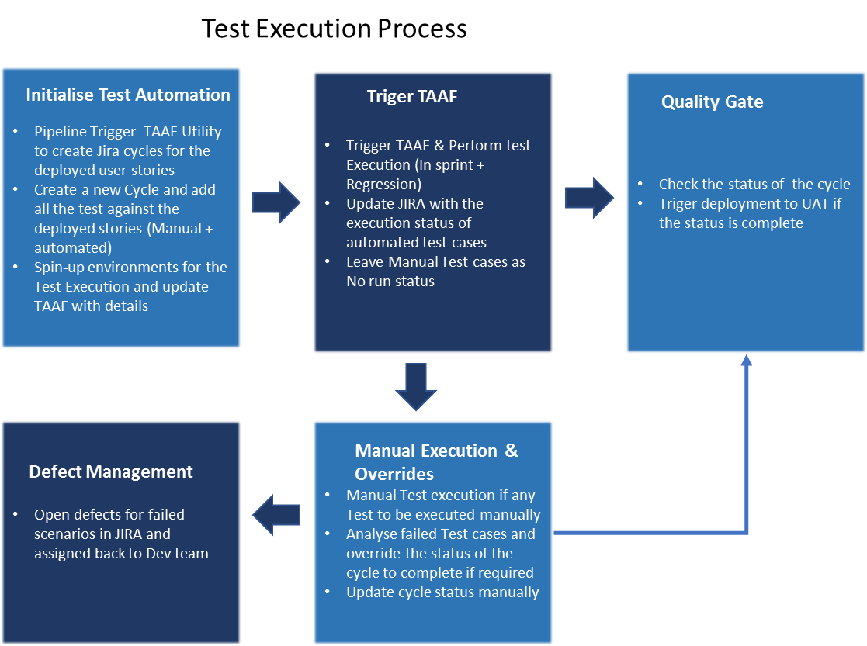

The test execution status will be updated to JIRA manually until the devops platforms are integrated.

## Test Automation Framework

Tool Agnostic Automation Framework (TAAF) will be used for automating the tests.

TAAF is an Automation Framework to support end to end process across multiple technologies and implement the automated test suites across the Experian solutions. It supports automated testing for Web, API and Mainframe projects/ products across the Experian Solutions

The tool is integrated with Experian OKTA and can be accessed with Experian Lan ID and password.

## Version Control

QA team use bitbucket for storing all automated test scripts and automation framework components. The manual test cases are stored in JIRA.

## Non - Functional Testing

This section will be updated once the NFRs are available.

### Performance Testing

Release level performance tests will be planned for the NFRs once it is shared. The tests are identified and developed as per the inputs from the Product Team and is executed once the functional and regression tests are complete. These tests will be carried out on the UAT (TBD) branch and will be testing the application/module/API for the peak expected loads as derived from the performance requirements.

### Multi browser Testing

Latest Chrome browser will be used for functional & Regression test execution. A set of test cases will be identified for browser compatibility testing for following browsers:

1. Firefox
2. Internet Explorer 11
3. Microsoft Edge

The list will be updated after the final confirmation from business.

## Test Data Management

* BI data (QAT) will be used for Business Search, Director search. etc
* Open Banking Journey will be tested with test accounts in a dummy bank (LoremBank) created by Runpath.
* For Management Accounts journey, there are about five test accounts setup in Codat that will be used

Note: This section will be updated once the detailed discussions on test data set up are complete.

## Sprint Closure Activities

QA team will be involved in following sprint closure activities:

* Demo of important features implemented as part of Sprint [Show & Tell session]
* Participate in sprint ceremony ‘Retrospective’ and log information on ‘what went well’ and ‘what can be improved’ in next sprint.
* Present the final statistics of features planned against actual to ensure any re-planning for incomplete items

## JIRA work Flow of a Story

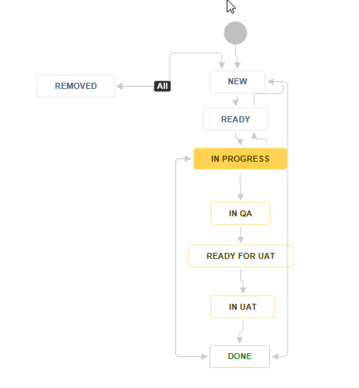

## Test Environments

QA team use QAT environment for functional and regression tests.

URL: <http://client-bis-uk-bosun-qa.apps.appcanvas.net/>

UAT environment will be used for performance testing.

URL: <https://client-bis-uk-bosun-uat.b-internal.appcanvas.net/>

## Test Tool Set

|  |  |
| --- | --- |
| **Activity** | **Tool** |
| Static Testing | In-house tool in JIRA |
| Test Case Management | JIRA with Zephyr |
| Defect management | JIRA Global |
| Sprint task allocation | JIRA Global |
| Reporting | JIRA reports |
| Automation | TAAF (JAVA, Selenium) |
| Performance Testing | JMeter |

## Defect Management

JIRA is used as Defect Management Tool for raising bugs, analysis of bugs and closing the bugs after validation.

## Work Flow

This section will be updated after the defect work flow is confirmed by TDO.

## Defect Priorities

The importance of fixing a defect will be set by the team initially and can re-prioritise based on the Defect Triage meetings conducted by Test Lead.

* **Blocker** – Show Stopper, prevents business from continuing
* **Critical** - The problem affects selected processing to a significant degree, making it inoperable, causes data loss, or could cause a user to make an incorrect decision or entry
* **Major** - The problem affects selected processing, but has a work-around that allows continued processing and testing
* **Minor** – Testing can continue. Includes problems which do not allow testers to perform a minor function or process which does not need a workaround
* **Trivial** - The problem is cosmetic, and/or does not affect further processing and testing

## Defect SLAs

The proposed analysis/triage and development SLAs. This may be amended once agreed by all relevant stakeholders. Prioritisation of defects for all testing types will be reviewed daily as part of triage process.

|  |  |  |
| --- | --- | --- |
| **Priority** | **Analysis SLA** | **Development SLA** |
| Blocker | Resolved within ½ a working day | Fix required within 1 working day |
| Critical | Resolved within 1 working day | Fix required within 3 working days. |
| Major | Resolved within 2 working days | Fix required within 5 working days or  next scheduled build |
| Minor | Resolved within 5 working days | Fix required within 10 working days or  planned for future build |
| Trivial | n/a | Will be fixed in next planned version of  bug fixes during testing phase |

## Defect Triage & Roles

QA team will raise defects in JIRA and assign to Dev Lead with an initial Priority and severity (based on above definitions). There is a communication channel available in Microsoft Teams to discuss the defects if any of the team has any queries. Test Lead will facilitate defect meeting based on the need. E.g., if the number of open defects are more or any critical issues to be addressed / prioritised.

Following table enumerates the role and responsibility of each role in a defect triage meeting.

|  |  |
| --- | --- |
| **Role** | **Responsibility** |
| Test Analysts | Submission of Bug Report |
| Test Lead | Convene Defect Triage Meetings |
| Development Lead | Assessment of Bug Report |
| Developers | Clarifications of bug if any |
| Product Owner | Confirmation of bug if required |
| Scrum Master | Communication of bug to stakeholders if required |

## Test Management Governance

## Team structure

|  |  |
| --- | --- |
| **Resource Type** | **Role** |
| Onshore Test Lead | Overall Ownership of delivery from testing side  Offshore coordination and Automation Specific Technical Direction  Involvement in Automation & Manual test Development / Execution Review |
| Test Analysts | Manual test design and execution  Automated Test Execution |
| Automation Analyst | Automated Test Design & Execution  Framework Updating and Maintenance |

## Escalation Matrix

|  |  |  |  |
| --- | --- | --- | --- |
| **Role** | **Level 1** | **Level 2** | **Level 3** |
| Test Analysts | Arunkumar Aickarakunnel Ammini <Arunkumar.AickarakunnelAmmini@experian.com> | Padmakrishnan Padmanabhadas <Padmakrishnan.Padmanabhadas@experian.com> | Sooraj Shanmughan <Sooraj.Shanmughan@experian.com> |
| Onshore Test Lead | Padmakrishnan Padmanabhadas <Padmakrishnan.Padmanabhadas@experian.com> | Sooraj Shanmughan <Sooraj.Shanmughan@experian.com> |  |

## Team Meetings

|  |  |  |  |
| --- | --- | --- | --- |
| Meeting | Attendees | Frequency | Objectives |
| Daily stand-up | Bosun Team | Daily | * Status Update * Issue Escalation & tracking * Project Co ordination |
| Sprint Planning | Bosun Team | Twice in a Month | Sprint Planning |
| Sprint Review | Bosun Team, Other stakeholders | Twice in a Month | * Assess the project against the sprint goal determined during the sprint planning * Demo |
| Team Retro | Bosun Team | Twice in a Month | Log information on “what went well” and “what can be improved” in further sprints. |

## Roles and Responsibilities

### RACI Matrix

**Legend:**

A – Accountable R – Responsible I – Inform C – Consult

TA -Test Analyst, TL – Test Lead, PO – Product Owner, DM – Scrum Master

|  |  |  |  |  |
| --- | --- | --- | --- | --- |
| **Task** | **TA** | **TL** | **PO** | **SM** |
| Static Testing | R | A | I | C |
| Test Estimation | R | A | I | C |
| Test Design | R | A | I | C |
| Test Case Review | R | A | I | C |
| Test Execution | R | A | I | C |
| Automation Test Design | R | A | I | C |
| Defect Closure | R | A | I | C |
| QA Signoff |  | R | A | C |

|  |  |
| --- | --- |
| **Roles** | **Responsibilities** |
| Test Analysts | Requirements discussions, Test Estimations, Test Case Design, Test Execution, Defect Management |
| Test Lead | Participate in stakeholder discussions, Provide High Level Test Estimates, review the test estimates of Test Analysts, Update Test Strategy as required, evaluate quality of testing performed, Provide QA Signoff |

## Risk & Issues

Risks identified during the project shall be monitored by the project team and discussed with the project stakeholders during the daily status meeting.

The objective of this section is to detail the current set of risks and issues that are identified as part of test planning exercise, which will enable the project teams in identifying, analysing and responding to risks throughout the project lifecycle.

|  |  |
| --- | --- |
| **Description** | **Mitigating Action** |
| Open banking and Management accounts journey need to be tested with Fake accounts or dummy data | TBD  (Checking with Team on possibilities of release level testing) |
| Pipeline & Test Automation tool integration is not ready. | TAAF tool will used in standalone mode and results will updated back to JIRA manually |

# User Acceptance Testing (UAT)

## UAT Approach

UAT Test approach for the Boson project is as follows:

* Acceptance testing based on defined and agreed Acceptance Criteria for Features
* Exploratory Testing – Time boxed test charters for high risk/complex Features
* End to End testing at Product Level for a Lender. (Happy/Unhappy paths)
* End to End testing at Product Level for an SME (Happy/Unhappy paths)
* Regression testing (Automated Regression Pack

## Assumptions

* UAT tester should be involved in defining the Acceptance Criteria with the Product owner.
* Happy and unhappy paths are defined and agreed.
* Invisionapp Demo to be used as basis for End to End test flows
* Granular Story level testing has been completed via the QA Team and Demos provided
* All Stories are marked as “Done” within the relevant Feature
* Test data is made available. *
* Runpath test data is made available, e.g. accountancy software, bank connections, etc.
* Test Automation is available for Regression testing QAT and UAT regions
* QA support

* UAT Bureau data is to be used for SME Businesses in conjunction with test cases (Individuals/Directors) identified via the Consumer Test Database (CTD). The CTD test cases will have been identified as “Positive” Authenticated prior to testing.

# Appendix

## Change History

|  |  |  |  |
| --- | --- | --- | --- |
| Date | Version | Author | Details |
| 16/04/2019 | Initial | Arunkumar | Initial Draft |
| 22/05/2019 | V2.0 | Craig Smith | Updated UAT details |
|  |  |  |  |
|  |  |  |  |
|  |  |  |  |
|  |  |  |  |

## Approval Record

|  |  |  |
| --- | --- | --- |
| Major Version | Approved By | Departments |
| Bosun Test Strategy v0.1 | Not Approved |  |
|  |  |  |

## Definitions and Acronyms

|  |  |  |
| --- | --- | --- |
| **Term** | **Acronym** | **Definition** |
| Development | Dev | Member of the team that writes code |
| Business Analyst | BA | Member of the team who carries out analysis of business requirements |
| Quality Assurance | QA | Member of the team that tests functionality to ensure it works as per requirements |
| User Acceptance Testing | UAT | Testing carried out by end users to ensure that the system meets requirements. |
| Small Medium Enterprises | SME | A small or medium-sized enterprise, or SME, as defined by the European Commission is a business or company: that has fewer than 250 employees. |
| Minimum Viable Product | MVP | Minimum Viable Product for a User |
| Tool Agnostic Automation Framework | TAAF | Test Automation tool |